World Cup 2020

The NK-FNJP is proud to host the world championships. In November 2017 the CIJB officially assigned the worlds to Belgium.
In this document, you will find all the necessary information.
The world cup 2020 will be held from the 02nd August till the 08th of August 2020
The opening ceremony will be host in the capital of Belgium in at the prestigious « Grand Place »
The competition and slot ceremony will be host by the beautiful city of Ath!
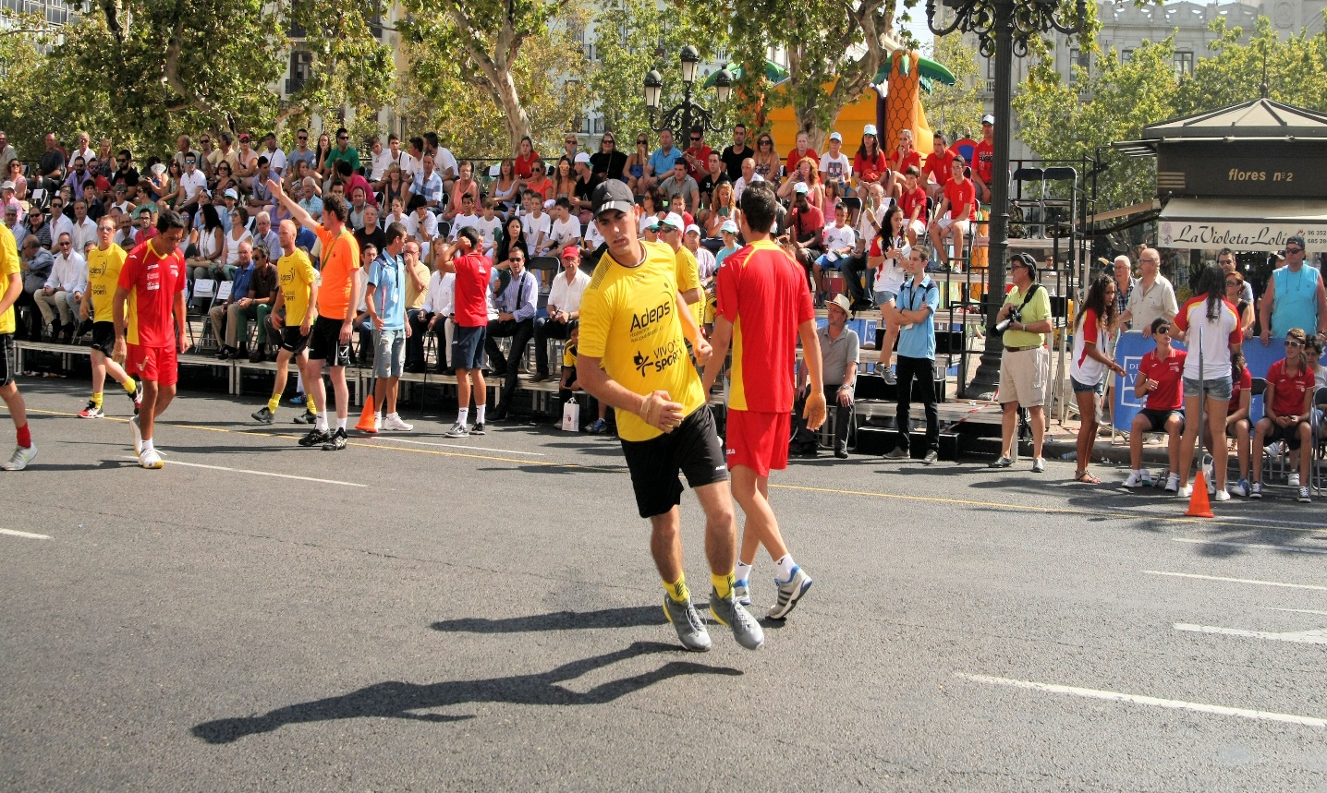
- Opening Ceremony
The opening ceremony will take place on Sunday the 02nd of August. The ceremony will be held during the traditional “Grand Prix of Brussels with the 4th best teams in Belgium”. The ceremony will take place at the Grand Place of Brussels, one of the most beautiful sceneries in the world.
All delegation needs to be at the official hotel on Sunday the 02nd of August at 12.00 o’clock. The transport will be granted and organized by NK-FNJP.
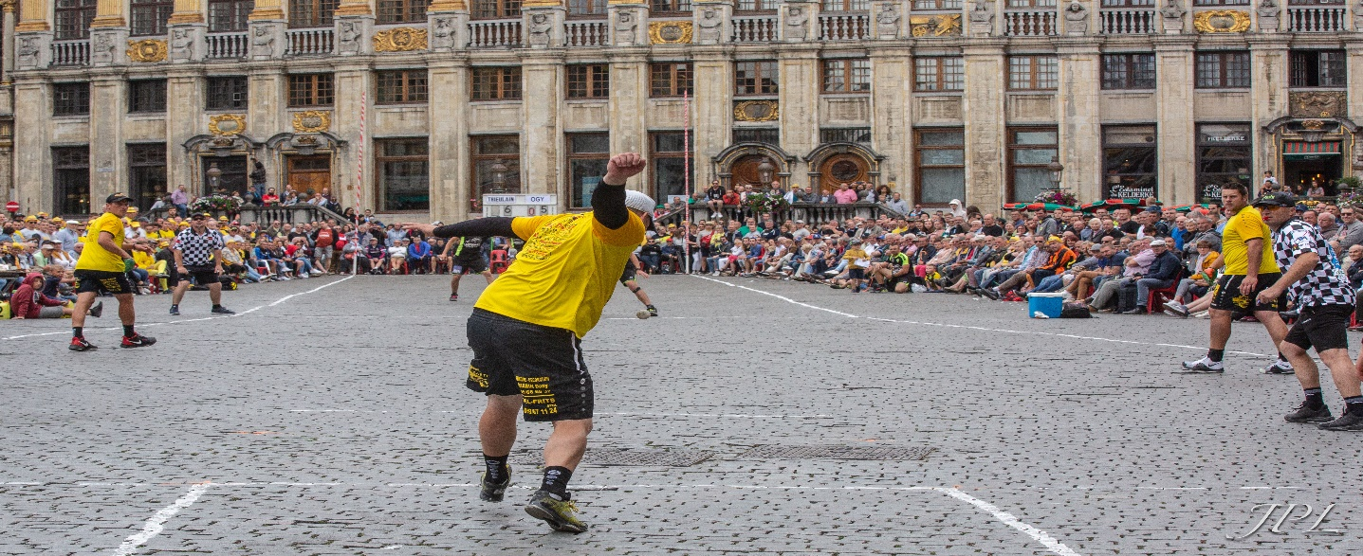

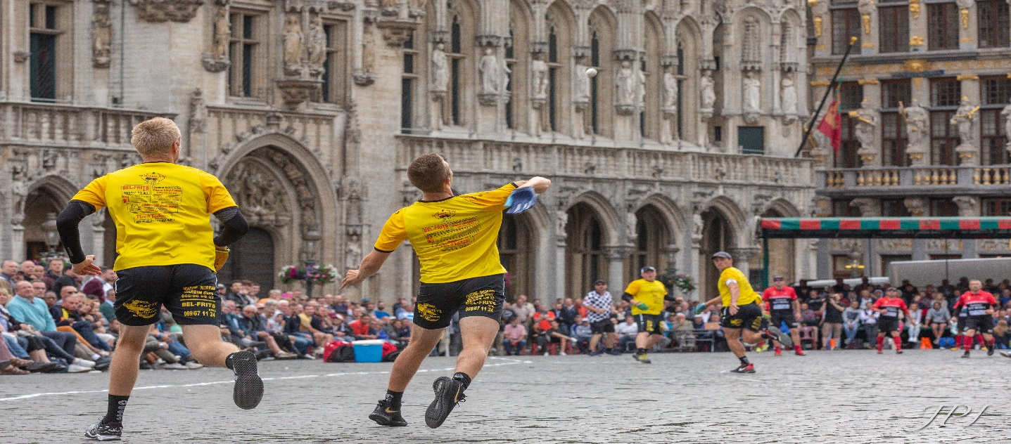
- Calendar
Below you will find the calendar. The official draw will be on Saturday the 15th of February during the board meeting of the CIJB in Belgium. The tournament schedule will be provided to all delegations.

- Monday 03/08/20: Traditional local game “ Jeu de Balle” & International Game Women
- Tuesday 04/08/20: International game Men & Finals International Game Women
- Wednesday 05/08/20: Finals international game Men & One Wall Singles Ladies + Finals One Wall Singles Ladies
- Thursday 06/08/20: One Wall Doubles Men & One Wall Doubles Ladies
- Friday 07/08/20: Llargues + Finals One Wall Double Men & Finals One Wall Doubles Ladies
- Saturday 08/08/20: Semi-Finals + Final Llargues
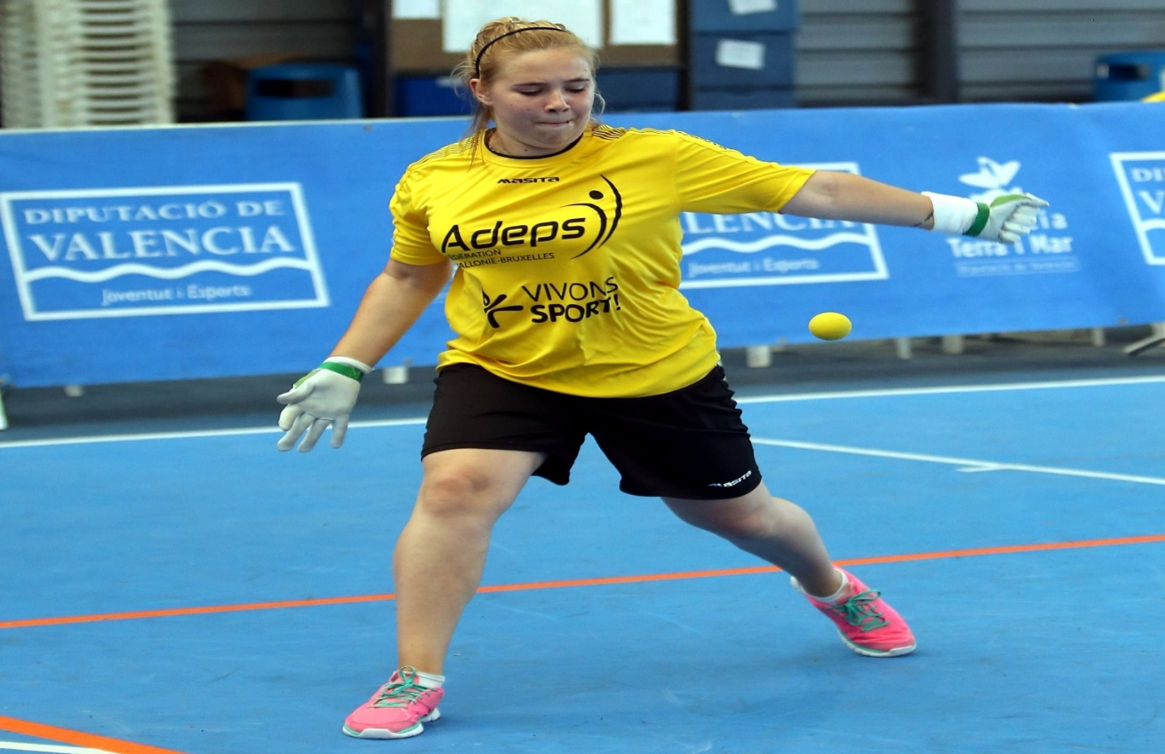

- Location
All the competitions will be host by the beautiful town of Ath. Ath is a Belgian municipality located in the Walloon province of Hainaut. The slot ceremony and awards will also be at the town hall of Ath.
Ath is known as the "City of Giants" after the Ducasse d'Ath festivities which take place every year on the fourth weekend in August. Huge figures representing Goliath, Samson, and other allegoric figures are paraded through the streets, and Goliath's wedding and his famous fight with David are re-enacted.
Archaeological records show the existence of several Gallo-Roman settlements in the Ath area. The origin of the city of Ath, however, dates from around 1160, when Count Baudouin IV of Hainaut, bought some territory from his liegeman, Gilles de Trazegnies. A few years later, Baldwin built the Burbank Tower – which can still be seen today – to protect his new acquisition. The new city was soon given privileges and its newly built (1325) market hall on the Grand-Place began to attract residents.
In 1667, Ath was conquered in a single day by the army of Louis XIV and became the first French city of the Spanish Netherlands. Soon after, Vauban built new fortifications, which included eight bastions. The city suffered again at the hands of the French army in 1745. At the end of the 18th century, Ath counted about 7,300 inhabitants but the population count decreased in the first half of the 19th century.
The freed-up land assisted the town for the activities of a growing population. A new growth period took place between 1850 and 1914 driven by the forestry, agricultural (breweries, mills) and textile industries.
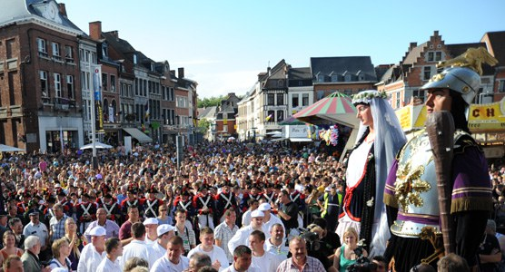
In the 20th century, most of these industries went into decline and were replaced by commercial, administrative and educational activities. In the last 30 years, several neighbourhoods have been revitalized and developed, and the city's monuments renovated or restored.

The disciplines “Lllargues” and “International Game” will be held on the “Esplanade of Ath”, located in the heart of the city of Ath.
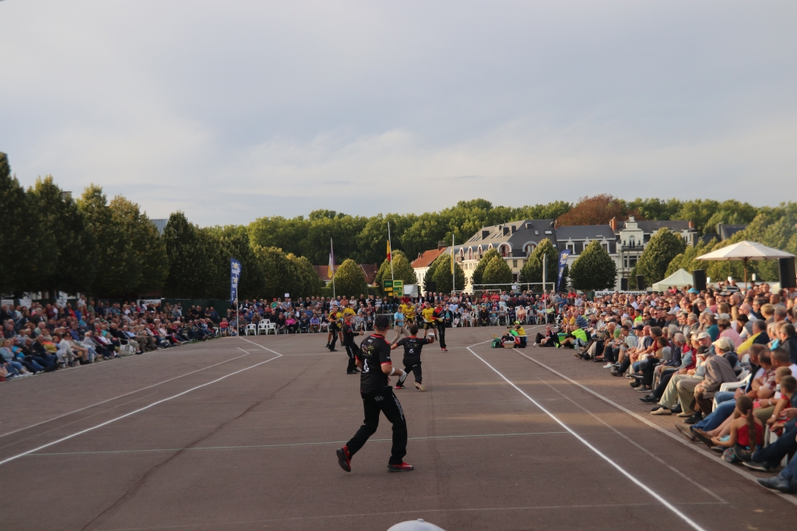

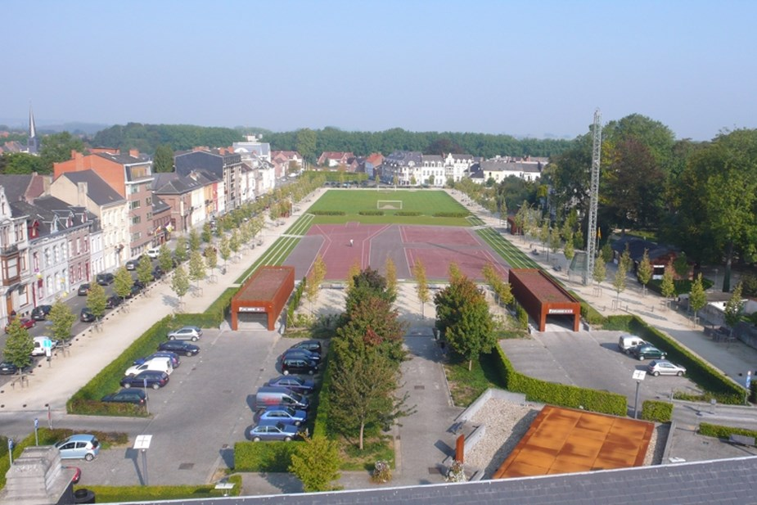
Sanitary facilities will be available for the teams.

The “One Wall” will be located in the “CEVA” The “CEVA” is the exposition and sports hall of the city of Ath. There will be 7 walls at disposal.
From the “esplanade” to the “CEVA” it’s only 5 minutes to walk.

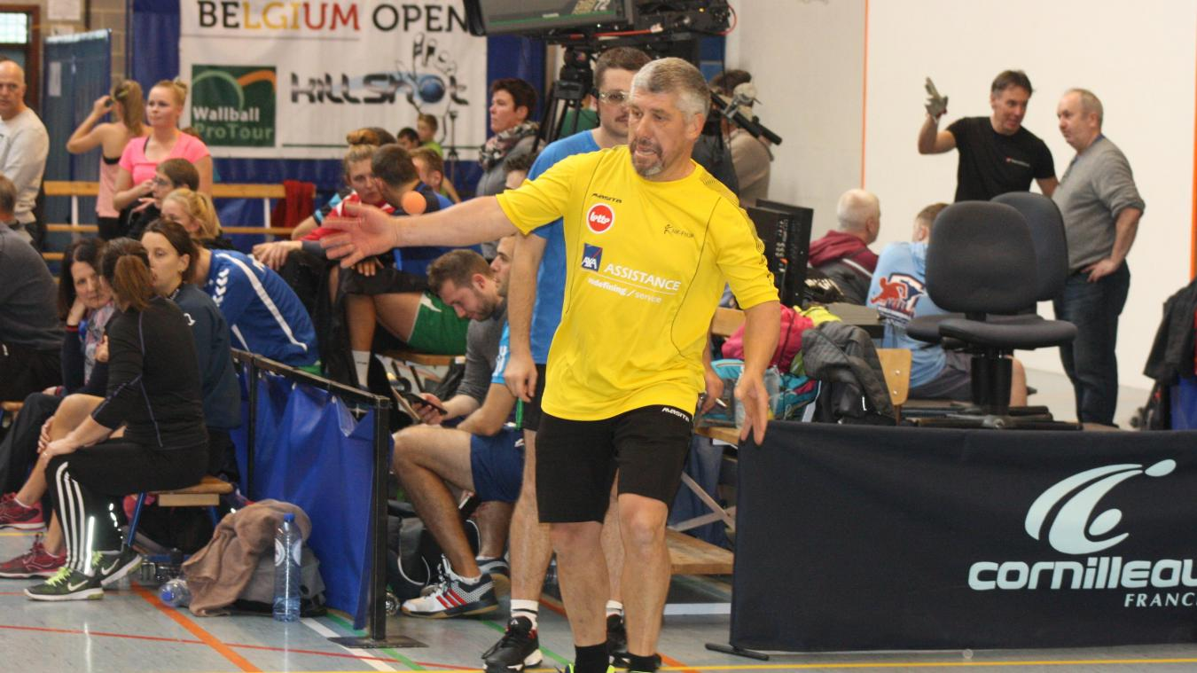

4.Hotel
The official hotel for all teams the teams and CIJB during the world cup from Sunday the 02nd of August till Saturday 08th of August included will be “Hotel Van Der Valk Nivelles-Sud”
https://www.hotelnivellessud.be/
The hotel was recently totally renovated.
The price of the hotel is 86,00 EUR p/p ( breakfast + city tax included)
Reservations need to be made through the following email address :
And in cc : dufourthierry7@gmail.com
The dinner for the teams offered by NK-FNJP will be also going on in “Hotel Van Der Valk Nivelles”
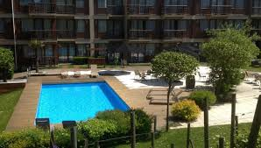

5.Practical Information
- Participation form will be sent separately and needs to be completed before the 15th of January.
- Transport will be granted by NK-FNJP from airport to the hotel
- The transport will be granted only for the team members with official accreditation.
- In accordance with the rules of the CIJB team will be composed :
11 man
5 woman
4 staff members
- The dinner takes in charge by NK-FNJP will be for 20 man
- Transport will be daily provided at morning and evening from the hotel to the play courts for the teams. No accreditation no transport.
- If you have any questions sent email to dufourthierry7@gmail.com
- Next slide you will find some more practical info about the traditional game “jeu de balle” and the official CIJB rules for the other disciplines.

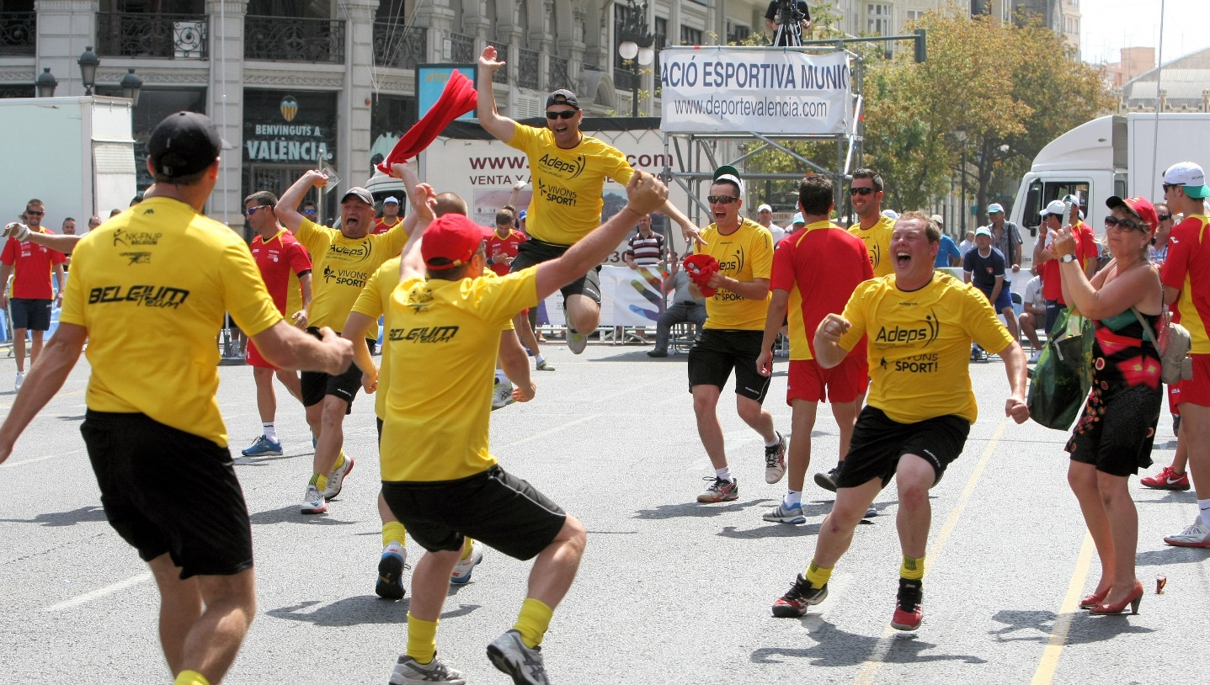

6. “Jeu de Balle” + Rules CIJB
- 2 teams of each 5 players + 1 substitute
- The team that wins 6 games wins the match
- To win a game you need to win 4 “fifteens” ( same as in tennis , but no advantage on 40-40)
- The service is with the naked hand
- The receivers/hitters play with a glove
- The goal is to invade the opponent as far as possible and kill the ball.
- The referee indicates with chalk the place where the ball stopped (chasse).
- “chasse” is a fictional net that moves on the ballot depending on the game.
- When two “chasses” are marked, the teams change ground and must take the hunts, that is to say, invade the opposing side and stop the ball in front of the first “chasse”.
- We play then for the second “chasse”
- Direct winning shots are: service or hitting over the limits of the playground
- The ball is playable until it bounces twice on the ground.
- A team can not touch the ball twice in a row
- Neither contact nor obstruction between players is allowed

Playground :
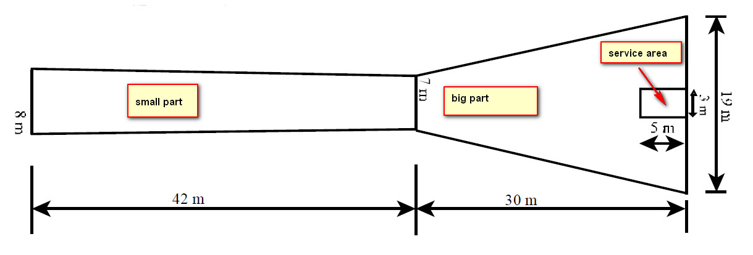

Glove:
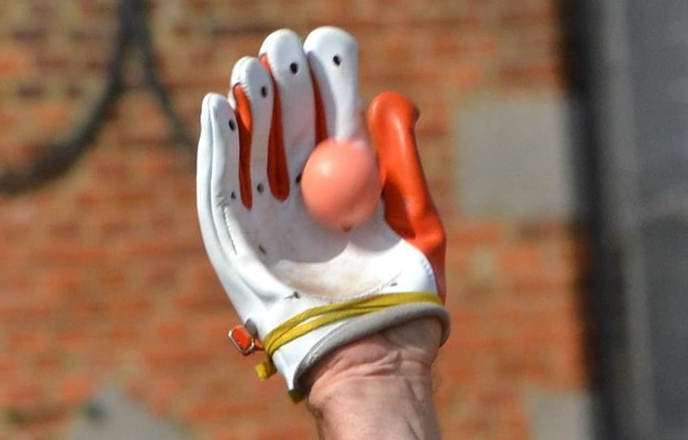
Chasse :
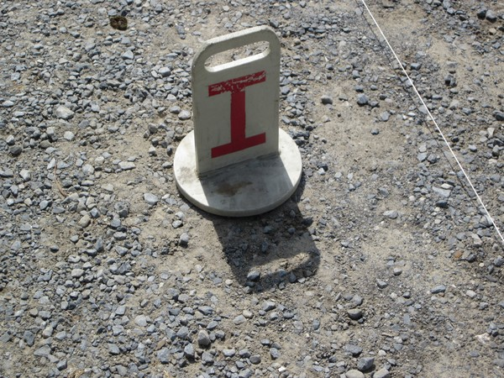

Video : https://www.youtube.com/watch?v=Tkq9_axAVXA&feature=youtu.be
https://www.youtube.com/watch?v=Ed9viBCZFzI&feature=youtu.be

Gloves and balls will be provided to the teams who will participate in the local game.

Official Rules CIJB :
outu.be/Tkq9_axAVXA
7. Questions :
Email: dufourthierry7@gmail.com Whatsapp: +32475610077
Photo credits:Tony Vandecasteele & Jean Pierre Lallemant– photos may not be used without permission
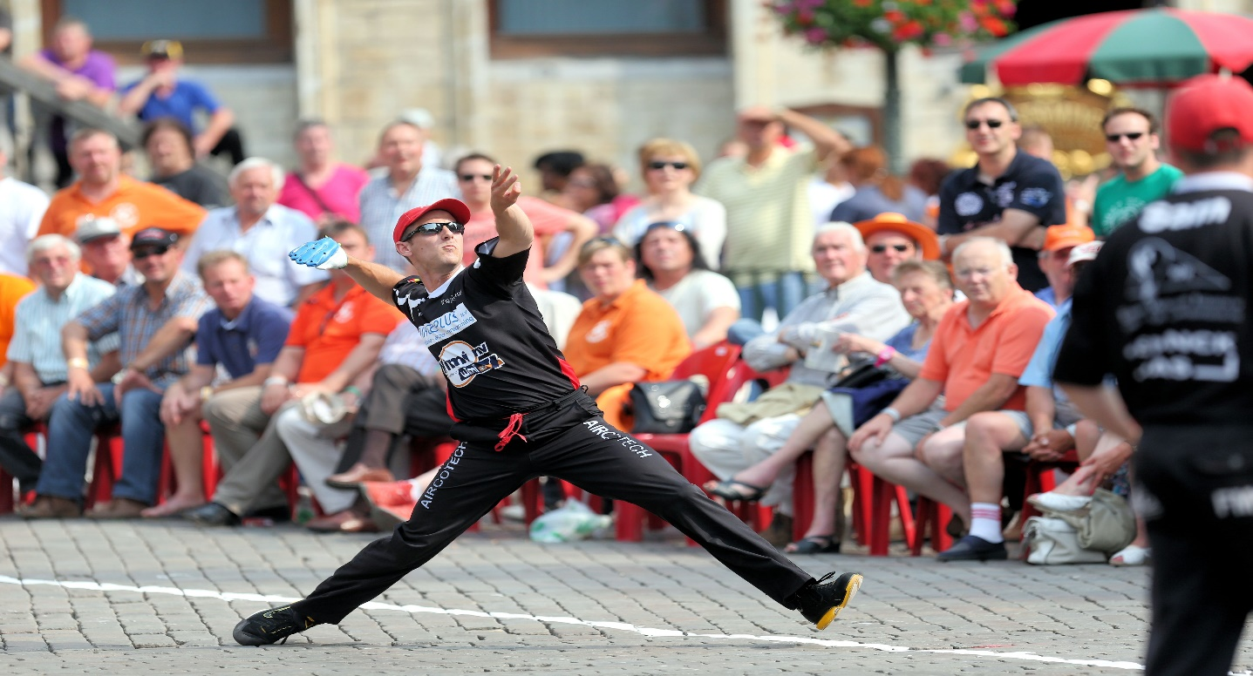
Responsible publisher: Thierry Dufour – NK-FNJP seconde chasse.

